User 4 — NFC Rescue Card
User Story
As a kind passer-by, if I find a lost pet, I hope to contact its owner as soon as possible. Therefore, after tapping the NFC tag, I expect to instantly view the pet’s key information and the owner’s contact details. This saves time and helps the pet get back home quickly.

User Activity
·The user was asked to imagine finding a lost pet wearing the Pawtrace NFC tag.
·The NFC scanning process was demonstrated to the user.
·The user was asked to open the pet identity card independently.
·The user was instructed to locate the owner’s contact information.
·The user was asked whether logging in or registering for the app would be acceptable in such an emergency.
User Validation Criteria
Metric | Target / Standard
Task completion rate | User can find the owner’s contact information without help.
Time | User can reach the owner’s contact information within 20 seconds after scanning.
Interaction count | The rescue flow should take no more than 2 clicks after scanning.
Friction evidence | If the user hesitates at login, asks why login is required, or says they would give up, this counts as a critical issue.
Quote evidence | At least one direct quote is recorded about whether login is acceptable in a rescue situation.
User Feedback

Before optimisation, User 4 was blocked by login or registration steps before accessing the pet identity card. This was a critical flaw because the NFC Rescue Card is designed for emergency lost-pet rescue scenarios. Passers-by may be in a hurry or unwilling to share personal information, and they may resist creating a new app account just to help a lost pet return home.
Quantitative evidence before optimization:
- Pet identity card access success rate: Blocked without app login
- Contact information retrieval time: Delayed by mandatory login / registration steps
- Rescue process convenience: Needs improvement; the user believed login and registration should not be required
Iteration Result
Key iteration: Mandatory login was removed from the NFC rescue process.
After optimisation, the pet identity card opens directly once the NFC tag is scanned. Users can view key rescue information and the owner’s contact details without creating an app account.
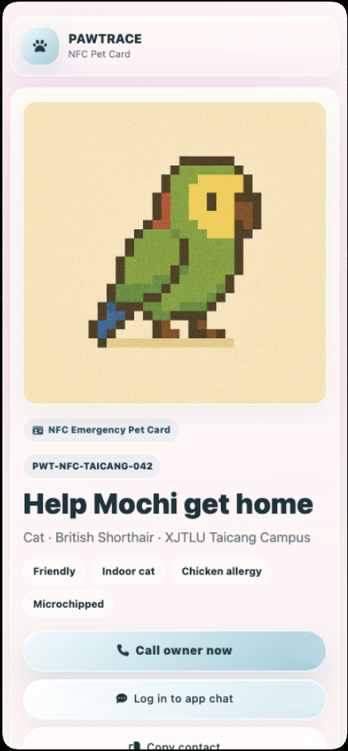
Quantitative evidence after optimization:
- Identity card access success rate in test scenarios: 100%
- Time required to access contact information: Within 10 seconds
- Interaction steps: ≤ 2 clicks after scanning
- Target rescue convenience score: ≥ 4/5
This iteration removed unnecessary barriers and made the NFC Rescue Card more suitable for emergency lost-pet recovery scenarios.

